GLITCHES IN THE SYSTEM

What do you do if the parent can’t check in their kids because they didn’t enter in the grade (unassigned room error)?
1) There is no way to edit their details once they have saved their profile.
2) You will need the JAM PC to edit details.

- Plug in the PC and turn on  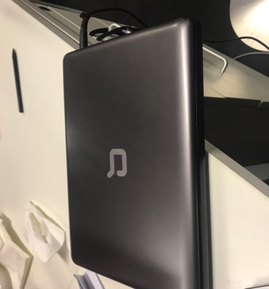 | - Password is JAM  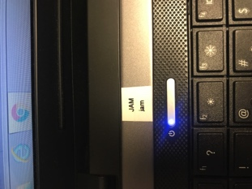
- Go into Google Chrome | - Go into Blue “People" Planning Centre Tab on top bar  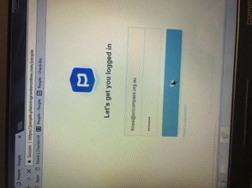  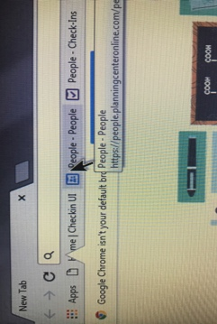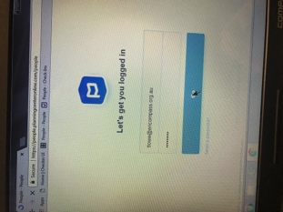
- Look up name, and edit/add details required and press save  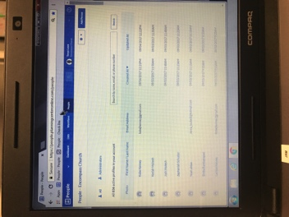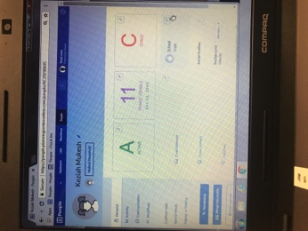  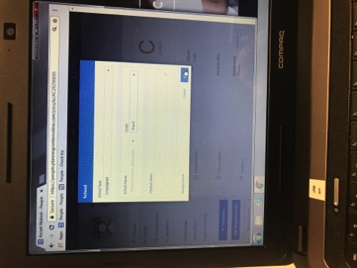 | F) The parents can go back to the iPad and they should be able to check in fine

What if they press save before they add the whole family?
1) Go back to the start, repeat the new people process and “Add to Existing Household"

What if parents mobiles changes or they want to amend incorrect details?
1) Get the parent to fill out the “eKids Registration Amendment Form"
2) Leave the form in the blue folder

What if parents can’t remember their phone number to check in?
1) Use the New People iPad (Black) and look up the child via the name instead of number OR look up and edit their details on JAM Laptop
2) AND fill out “eKids Registration Amendment Form"

What if the black check in button doesn’t appear on the check in page? (This can happen if kids are going to multiple services)
1) Press on the kids name and select the room they are going into
2) Select the room/service they are going into
3) Check in as per normal

