CHECK IN PROCESSES
NEW PEOPLE REGISTRATIONS
Greet suspected new person ‘Hi Welcome to Church today, is this your first time?
- Type any letter and search  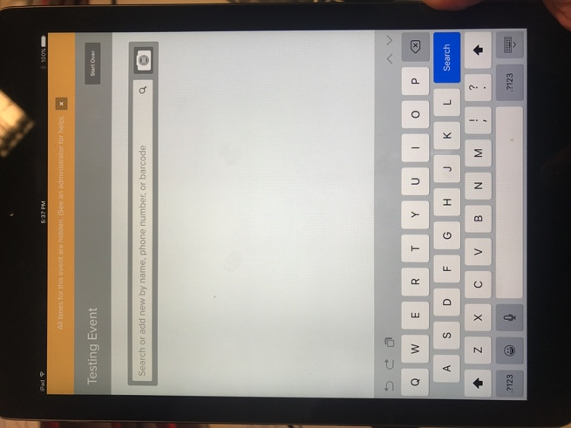 | - Click on "New Person" button which appears on top RH corner  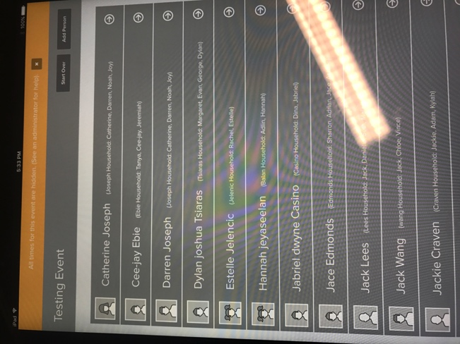
- Decide what type of new person they are.  A) Add to a New Household (this is for a family new to our church)  B) Add to an Existing Household (this for an existing family adding a new parent/child to their current household)  C) Create a Temporary One-Time Guest (this is for visitors who don’t intend to come back e.g. Live overseas, family friend’s kids)  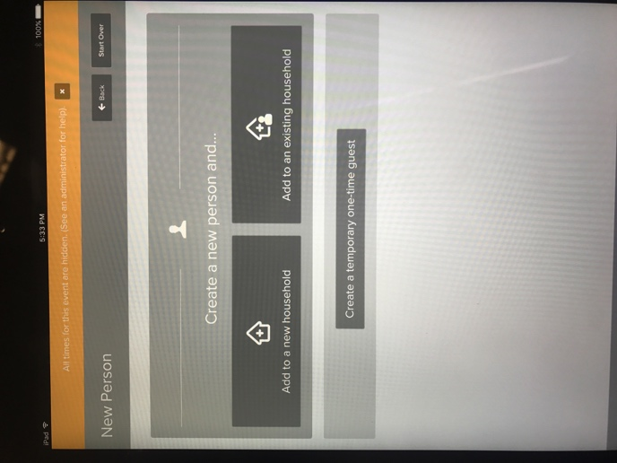 | - Enter in family details, starting with the parents details and keep pressing “Add New” at the top until the whole family is added.  Please note: If the grade is not entered in, kids will not be able to check in as the system doesn’t know what room to send them to. Kids who are in preschool are entered as Pre-K. Kids in Prep are entered as K and the rest are as per normal. 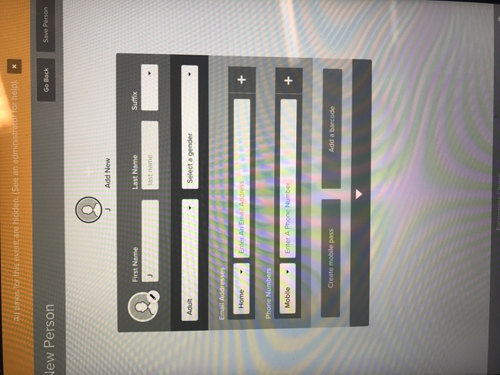
- Save the Family by pressing “Save Person” at the top RH corner of screen. This will take you to the check in screen | - Check in the kids attending and pick up labels from the printer. Explain the parents label and pick up process with parents

